# Default Market Offer

# Post-review consultation

Implementation of the 2022 review outcomes of the Competition and Consumer (Industry Code – Electricity Retail) Regulations 2019

© Commonwealth of Australia 2023

**Ownership of intellectual property rights**

Unless otherwise noted, copyright (and any other intellectual property rights) in this publication is owned by the Commonwealth of Australia (referred to as the Commonwealth).

**Creative Commons licence**

All material in this publication is licensed under a [Creative Commons Attribution 4.0 International Licence](https://creativecommons.org/licenses/by/4.0/legalcode) except content supplied by third parties, logos and the Commonwealth Coat of Arms.

Inquiries about the licence and any use of this document should be emailed to [copyright@dcceew.gov.au](mailto:copyright@dcceew.gov.au).



**Cataloguing data**

This publication (and any material sourced from it) should be attributed as: DCCEEW 2023, *Default Market Offer*

*Post-review consultation*, Department of Climate Change, Energy, the Environment and Water, Canberra.

Department of Climate Change, Energy, the Environment and Water

GPO Box 3090 Canberra ACT 2601

Telephone 1800 900 090

Web [dcceew.gov.au](https://www.dcceew.gov.au)

**Disclaimer**

The Australian Government acting through the Department of Climate Change, Energy, the Environment and Water has exercised due care and skill in preparing and compiling the information and data in this publication. Notwithstanding, the Department of Climate Change, Energy, the Environment and Water, its employees and advisers disclaim all liability, including liability for negligence and for any loss, damage, injury, expense or cost incurred by any person as a result of accessing, using or relying on any of the information or data in this publication to the maximum extent permitted by law.

**Acknowledgements**

The authors thank interview and survey participants for their input.

**Acknowledgement of Country**

We acknowledge the Traditional Custodians of Australia and their continuing connection to land and sea, waters, environment and community. We pay our respects to the Traditional Custodians of the lands we live and work on, their culture, and their Elders past and present.

Contents

1 About this paper 4

2 Introduction 5

2.1 Overview of the Code 5

3 Application of the Reference Price to complex offers 7

3.1 Directions paper findings 7

3.2 Proposed approach 7

4 Improving the understanding of the Reference Price for consumers 9

4.1 Directions paper findings 9

4.2 Proposed approach 9

5 Embedded network customer pricing protection 10

5.1 Directions paper findings 10

5.2 Proposed approach 11

6 Next steps 12

**Figures**

## About this paper

The purpose of this paper is to undertake further consultation on the outcomes from the 2022 Review of the *Competition and Consumer (Industry Code – Electricity Retail) Regulations 2019* (2022 DMO Review).

In accordance with the commitment in the explanatory statement for the Code, a review of the Code was conducted two years after its initial implementation. [Find out more Information on the review and its outcomes](https://www.energy.gov.au/government-priorities/energy-programs/price-safety-net). This paper should be read in conjunction with the [2022 DMO Review outcomes and associated consultation material](https://consult.dcceew.gov.au/review-of-dmo-and-reference-price).

The 2022 DMO Review provided five outcomes. The first outcome, changing the date of the DMO determination to a later date in May, has been completed. The fifth outcome is for the department to conduct a further review of the Code two years after implementation of the Consumer Data Right for Energy for initial retailers, which occurred in November 2022.

The three remaining outcomes from the 2022 DMO Review for consultation are:

* options to amend the name of the Reference Price to an alternative which better describes its function and improves consumer understanding;
* the application of the Reference Price to complex offers, including ensuring comparative advertising is available for complex offers; and
* how to extend price cap protection provided by the DMO to customers in embedded networks, including examination of compliance issues and costs.

All stakeholder submissions will be published unless stakeholders have clearly indicated a submission should remain confidential, either in whole or in part. Your personal information will be managed in accordance with the [department’s privacy policy](https://www.dcceew.gov.au/about/commitment/privacy).

Closing date for submissions: 21 April 2023. Electronic submissions are preferred.

|  |  |
| --- | --- |
| Email: | [electricitycode@dcceew.gov.au](mailto:electricitycode@dcceew.gov.au) |
| Mail: | Electricity Division – Consumer Energy Policy Department of Climate Change, Energy, the Environment and Water GPO Box 3090, Canberra ACT 2601, Australia |

## Introduction

On 20 August 2018, the Australian Government announced the implementation of a Default Market Offer (DMO) for retail electricity standing offers, as recommended by the Australian Competition and Consumer Commission (ACCC) in its Retail Electricity Pricing Inquiry. The Government also announced it would adopt the ACCC’s recommendation to use the DMO as a reference for comparing electricity prices.

The [Competition and Consumer (Industry Code – Electricity Retail) Regulations 2019](https://www.legislation.gov.au/Series/F2019L00530)(the Code)came into effect on 1 July 2019. It operates in New South Wales, South Australia, and South East Queensland (DMO jurisdictions[1] – Figure 1) by:

*Figure 1: DMO jurisdictions*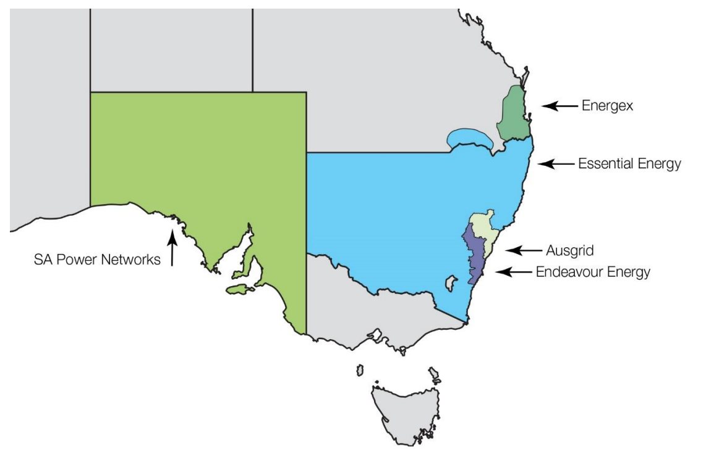

*Source: AER, 2019*

* applying the DMO price cap to standing offer prices available to certain residential and small business customers;
* requiring retailers to compare their prices to the DMO (called the reference price); and
* imposing specific requirements on the communicating of prices and advertising conditional discounts.

The Code also sets out the framework for the Australian Energy Regulator (AER) to make determinations that underpin the DMO. During volatile market conditions experienced in 2022, retailers have temporarily seen increased market pressures when balancing their wholesale price hedging positions to keep standing offer prices in line with the DMO. The AER has already undertaken consultation[2] to respond to recent market events to best address these market pressures in its next determination.

The Code operates nationally as part of the broader energy regulatory framework but sits outside the National Energy Customer Framework.

### Overview of the Code

The Code requires the AER to determine the annual supply price of electricity for types of average customers in jurisdictions covered by the Code. This determined annual supply price operates as the price cap[3] and Reference Price and requires that:

* a retailer’s standing offer must not exceed this price (the DMO); and
* the Reference Price must be used to compare certain advertised offers

The Code also prevents advertising a conditional discount as the headline discount in the advertised price to help improve transparency and clarity around discounts for consumers. Further, retailers must also clearly and conspicuously advertise the terms of any conditional discounts that form part of an offer.

The AER calculates an annual supply price for all DMO jurisdictions and for different types of customers having regard to the costs to supply electricity to those customers. However, the AER also has regard to other objectives such as not dis-incentivising customer engagement in the market and allowing retailers to compete and innovate. The AER is required to make a price determination (in each distribution region) for the following three customer types:

* a residential, non-controlled load, customer;
* a residential, controlled load, customer; and
* a small business customer.

In addition to recordkeeping requirements, amendments to the Code in February 2020 extended:

* the Code, to cover small customers with solar photovoltaic (PV) systems;
* the cap on standing offer prices, to residential customers on flexible tariffs; and
* the Reference Price comparison obligation, to price variation notices.

These amendments resulted in customers with grid-feeding solar photovoltaic units who also classify as one of the three customers types listed above as being covered by the Code. However, calculations of solar customer feed-in tariffs are not included.

The Code does not apply where the standing offer price is already regulated, to small distribution regions with less than 100,000 consumers, or to small customers under the following supply arrangements:

* embedded networks;
* prepayment meters; and
* where the prices for the supply include a demand tariff.

## Application of the Reference Price to complex offers

|  |
| --- |
| We are consulting on the application of the Reference Price to complex offers, including ensuring comparative advertising is available for complex offers. |

### Directions paper findings

All submissions supported further consultation on how the reference price operates across the range of offers provided by retailers, particularly more complex offers.

Stakeholders recognised that the existing reference price is a suitable comparison tool for traditional tariff structures but is not as useful for more complex types of offers.

The complex nature of some offers does not easily allow a meaningful comparison to the Reference Price as it may be difficult to define an average offering or an average user. Submissions also indicated it is important that this inability to easily compare offers should not restrict advertising of offers by retailers that would benefit consumers.

The retail market is rapidly changing with new technologies and products appearing frequently. We are consulting with stakeholders on if and how the Reference Price should be applied to advertising and comparing new and complex offers.

### Proposed approach

In areas without standing offer price regulation, the AER currently determines for each customer type and distribution area, the per-customer amount of electricity supplied in a year, the timing or pattern of the supply, and the per-customer annual price for that supply.

This makes the Reference Price a fit for purpose comparison tool for comparing market offers that are include flat or single rate, block, and time of use tariffs. Trying to compare more complex offers, for example wholesale cost pass through offers with a floating usage charge, provides a less useful comparison for consumers.

The Code does not apply to demand tariffs. Solar feed in tariffs are disregarded when calculating the comparison to the Reference Price. We want to encourage innovation in the sector, and we anticipate new complex offers emerging in this market.

We note requirements in the National Energy Retail Law and Rules, and Retail Pricing Information Guidelines apply to how retailers communicate their prices and offers. The [Retail Pricing Information Guidelines](https://www.aer.gov.au/system/files/AER%20Retail%20Pricing%20Information%20Guidelines%20-%20Version%205.0%20-%20April%202018.pdf) provides the AER the power to specify additional matters necessary or convenient to assist customers to consider and compare offer prices offered by retailers, including those more complex offers entering the market.

We propose defining the types of non-complex offers that are seen as providing on-going value to a consumer when compared to the Reference Price and limiting the application of the Reference Price communication requirements to those. This arrangement will continue to work in conjunction with the AER Retail Pricing Information Guidelines. This guideline can be updated to require additional information relating to price information to assist consumers to be able to consistently compare complex offers.

**Questions:**

1. Does applying the Reference Price exclusively to simple offers (defined as flat or single rate, block, and time of use, with and without controlled load) retain the ability for consumers to best compare the Reference Price for non-complex offers?

2. Does the above provide appropriate flexibility for retailers to advertise complex offers?

3. Are there any unintended consequences from adopting this approach?

4. Do you have any implementation concerns regarding timing or otherwise?

## Improving the understanding of the Reference Price for consumers

|  |
| --- |
| We are consulting on options to amend the name of the Reference Price to an alternative which better describes its function and improves consumer understanding. |

### Directions paper findings

The directions paper sought views on using the term “comparison price set by Government” rather than “Reference Price” to improve consumer understanding of the purpose of the Reference Price and how it could be used by consumers.

Retailers are required to compare prices to the Reference Price whenever they advertise or publish the prices, offer to supply electricity at the prices, or notify a customer of a price change.

Submissions generally supported changing the term Reference Price to a term that better reflects its purpose. Many submissions supported the name change to “comparison price set by Government”, however, others thought that other wording options should be tested. Some stakeholders were also concerned that changing the wording would confuse consumers and may cause inconsistencies with the terms used in Victoria and the ACT

Some stakeholders considered that the proposed wording was too long to include in advertising material and also suggested removing other requirements, such as the “lowest possible price” requirement.

### Proposed approach

We propose that retailers be required to use the term “comparison price set by government” when stating a comparison to the Reference Price. The components of this term have been empirically tested, describes the function, and is expected to provide an increased consumer understanding. [Read the Testing comprehension of the reference price report](https://www.accc.gov.au/system/files/BIT%20Final%20report%20-%20Testing%20comprehension%20of%20the%20reference%20price.pdf).

We also propose removing the small print advertising requirement of “lowest possible price”.

**Questions:**

5. Do you have any other alternative terms that have been user-tested that would improve understanding and use of the Reference Price comparison by consumers? If so, can you please provide the testing and data for us to consider.

6. Do you see any unintended consequences of removing the small print term “lowest possible price”?

7. Do you have any implementation concerns regarding timing or otherwise?

## Embedded network customer pricing protection

|  |
| --- |
| We are consulting on how to extend price protections provided by the DMO to customers in embedded networks, including examination of compliance issues and costs.  Communication requirements regarding the Reference Price will not be extended to embedded network providers. |

### Directions paper findings

All submissions commenting on this outcome supported further consultation on how best to extend DMO price protections to all customers of embedded networks.

Some stakeholders noted that the DMO price protections are already applied indirectly to embedded network customers purchasing electricity from AER exempt sellers[4]. Stakeholders were supportive of extending the DMO pricing protection to embedded network customers purchasing from Authorised Retailers[5]. This is particularly important as retailers are covering an increasing number of customers in embedded networks[6].

We acknowledge the complexity of embedded networks, particularly the compliance issues and implementation costs of extending DMO price protections to affected customers. We also note that visibility of small customers in embedded networks is somewhat limited due to nature of their regulatory arrangements. Given that, we are undertaking further detailed consultation on this matter.

For reference, consumers in embedded networks include those in apartment buildings, shopping centres, retirement villages, caravan parks, or marinas. These customers are normally serviced by either a retailer or exempt seller. Due to wiring and metering arrangements, some customers cannot access market offers and are limited to purchasing electricity from the embedded network provider. Customers with their own meter can sometimes access retailer energy-only[7] offers (on-market) and will still have to pay network charges to the embedded network provider. We understand that there are not many energy-only offers available from retailers.

### Proposed approach

The Code applies nationally to all retailers in jurisdictions where there are no regulated standing offer prices. Currently this is in New South Wales, South Australia and Southeast Queensland.

We propose extending pricing protections by ensuring prices offered by retailers to customers in embedded networks do not exceed the local standing offer.

We propose to extend the Code to cover electricity offers to customers embedded networks where they are not subject to price regulation. We propose to also extend the definition of *distribution region* to include connected embedded networks to ensure application of the Code to these small customers. We anticipate the DMO pricing determination for standing offers may need to highlight or in some way present network cost components, to support customers taking up energy-only offers.

It is not the intention that this price protection is considered as price setting. We acknowledge there could be cost savings available to retailers from combining the purchasing power of multiple consumers and we expect these savings to continue to be passed through to those consumers. Energy-only offers provided to customers by retailers in embedded networks should not include network costs as customers will still be charged network costs from the embedded network operator.

Some customers in embedded networks are supplied by exempt sellers, not retailers, and are therefore not covered by the Code. We understand that many jurisdictions have other pricing arrangements to protect these consumers. For example, customers in embedded networks that are supplied by an AER exempt seller currently have pricing protections through condition 7 of the AER Exempt Sellers Guidelines[8].

**Questions**:

8. Does this approach ensure that customers in embedded networks nationally receive pricing protection based on the local standing offer (or DMO)?

9. Are there any unintended consequences from adopting this approach, including any specific jurisdictional issues?

10. Do you have any implementation concerns regarding timing or otherwise?

## Next steps

We will undertake a public forum to discuss the issues with stakeholders. We will then collate and consider responses prior to seeking government approval of the outcomes. Any regulatory changes identified will then be implemented through normal regulatory change processes in due course.

1. The Code was designed to apply in jurisdictions which did not otherwise regulate standing offer

   prices or have less than 100,000 customers as defined in section 8 of the Code
2. Read the [AER Default market offer prices 2023-24 Issues paper](https://www.aer.gov.au/system/files/AER%20-%20Default%20market%20offer%20-%20Price%20determination%202023-24%20issues%20paper%20-%203%20November%202022_0.pdf)
3. The price cap does not limit the total costs for a consumer as that will be based on total energy use
4. ‘Exempt sellers’ are exempt from the requirement of the National Energy Retail Law that entities selling energy to premises must be an authorised retailer. The AER requires exempt sellers to abide by certain conditions that include consumer protections.
5. See the [Public register of authorised retailers & authorisation applications](https://www.aer.gov.au/retail-markets/authorisations/public-register-of-authorised-retailers-authorisation-applications)
6. Read the [Inquiry on Embedded Networks in New South Wales](https://www.parliament.nsw.gov.au/ladocs/inquiries/2873/Report%20-%20Embedded%20Networks%20in%20New%20South%20Wales.pdf)
7. Find more detail on energy-only offers
8. Read the [Retail Exempt Selling Guideline](https://www.aer.gov.au/system/files/AER%20-%20Final%20Retail%20Exempt%20Selling%20Guideline%20%28version%206%29.pdf)